# PROJECT TITLE: (comprehensive digital marketing for kay beauty)

# STUDENT NAME: Doki. Vishalini Venkata laxmi

# PROJECT SUPER VISIOR: DR. Varoodhini

# DEPARTMENT: BBA

# COLLEGE: Satya degree and PG college

# TEAM ID: LTVIP2025TMID24601

# INTRODUCTION

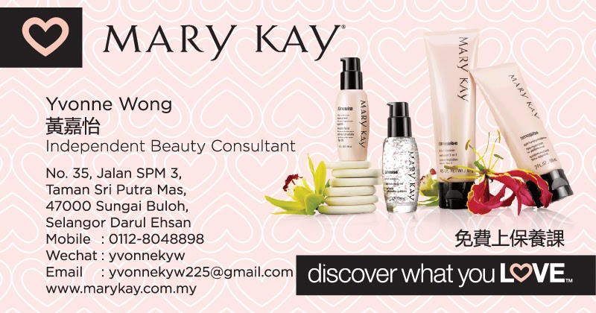

[This Photo](https://thexworks.blogspot.com/2016/10/business-card-design-mary-kay-beauty.html) by Unknown Author is licensed under [CC BY-NC-ND](https://creativecommons.org/licenses/by-nc-nd/3.0/)

ZCA comprehensive digital marketing strategy for **Kay Beauty**, a beauty brand (assuming it’s a beauty or cosmetics brand), would focus on leveraging various digital channels and strategies to build brand awareness, increase customer engagement, drive sales, and foster loyalty. Here's a detailed plan:

**1. Brand Positioning & Messaging**

* **Define Brand Voice & Values:** What makes Kay Beauty unique? It could be its focus on inclusivity, high-quality ingredients, cruelty-free products, etc.
* **Target Audience:** Focus on specific segments such as beauty enthusiasts, professionals, eco-conscious consumers, or a particular age group.

**2. Website Optimization & E-Commerce Strategy**

* **User-Friendly Website:** Ensure the website is easy to navigate, mobile-optimized, and visually aligns with the brand.
* **SEO Optimization:** Focus on both on-page (content, keywords, metadata) and off-page (backlinks) SEO to improve organic search visibility.
* **Product Pages:** High-quality images, clear descriptions, and customer reviews to drive trust and conversions.
* **E-Commerce Integration:** Simplify the checkout process, offer multiple payment options, and integrate features like "Add to Wishlist" or "Save for Later."
* **Landing Pages:** Use dedicated landing pages for promotions or specific collections (e.g., seasonal sales, new arrivals).

**3. Social Media Marketing**

* **Platform Selection:** Instagram, TikTok, Facebook, YouTube, and Pinterest are ideal for beauty brands.
* **Content Types:**
  + **Instagram:** Product showcases, behind-the-scenes content, tutorials, influencer collaborations, and user-generated content (UGC).
  + **TikTok:** Fun, engaging, viral content like makeup tutorials, quick tips, and challenges.
  + **Pinterest:** Post high-quality images of makeup looks, beauty hacks, and inspiration boards to attract organic traffic.
  + **YouTube:** Tutorials, reviews, beauty hacks, and influencer partnerships with in-depth product demonstrations.
* **Influencer Partnerships:** Collaborate with beauty influencers and micro-influencers for unboxing videos, product reviews, and tutorials.
* **User-Generated Content (UGC):** Encourage customers to share their photos and videos using branded hashtags, incentivizing them with giveaways or contests.

**4. Paid Advertising**

* **Facebook & Instagram Ads:** Run targeted ad campaigns to reach specific demographics with dynamic product ads, carousel ads, and video ads.
* **Google Ads (PPC):** Invest in search ads targeting high-intent keywords, such as “best cruelty-free foundation” or “Kay Beauty lipsticks.”
* **Display Ads:** Retarget visitors who have visited the website but didn’t convert with compelling offers.
* **YouTube Ads:** Consider skippable ads for brand awareness or non-skippable ads for product promotion.
* **Influencer Sponsorships:** Use paid partnerships with influencers to amplify your reach.

**5. Email Marketing**

* **Segmentation:** Segment your email list based on customer behavior, purchase history, location, etc., for more personalized campaigns.
* **Newsletters:** Share exclusive offers, product launches, or beauty tips through weekly or bi-weekly newsletters.
* **Automated Campaigns:**
  + Welcome Series for new subscribers.
  + Abandoned Cart emails to recover lost sales.
  + Post-purchase emails asking for reviews and offering related product recommendations.
* **Exclusive Offers & Loyalty Programs:** Encourage repeat purchases by offering loyalty rewards or exclusive discounts to subscribers.

**6. Content Marketing**

* **Blog:** Write SEO-optimized articles on beauty trends, product reviews, skin care tips, or how-to guides. Position Kay Beauty as a thought leader in the industry.
* **Video Content:** Use YouTube or Instagram to create tutorial videos, beauty hacks, product demonstrations, and testimonials.
* **SEO Strategy:** Focus on both short-tail (e.g., "best lipstick") and long-tail keywords (e.g., "long-lasting lipstick for oily skin"). Consider creating a keyword strategy that targets specific product types and beauty routines.

# BRAND STUDY, COMPETITIOR ANALYSIS AND BUYERS /AUDIENCE PERSONA

Creating **buyer personas** for Kay Beauty will help in tailoring marketing strategies, product development, and content to meet the needs and desires of different audience segments. Below are some example buyer personas for a beauty brand like Kay Beauty:

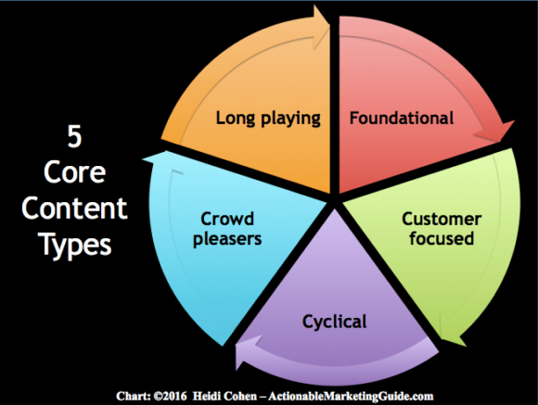

[This Photo](https://heidicohen.com/content-marketing-lessons-from-mom/) by Unknown Author is licensed under [CC BY-SA-NC](https://creativecommons.org/licenses/by-nc-sa/3.0/)

Certainly! Let's put together a **Brand Study**, **Competitor Analysis**, and **Buyers/Audience Persona** for **Kay Beauty**, a cosmetics or beauty brand. This comprehensive approach will help you understand Kay Beauty’s positioning, the competitive landscape, and the audiences it serves. Here's how to break it down:

**1. Brand Study for Kay Beauty**

**a. Brand Identity**

* **Mission & Vision:**
  + **Mission:** Kay Beauty’s mission is to offer high-quality, affordable beauty products that cater to all skin tones, promote self-expression, and empower individuals to feel confident in their skin.
  + **Vision:** To become a global leader in beauty that prioritizes inclusivity, sustainability, and innovation in every product.
* **Core Values:**
  + **Inclusivity:** Offering a wide range of shades to suit diverse skin tones.
  + **Affordability:** Making high-quality beauty accessible to everyone.
  + **Sustainability:** Using eco-friendly packaging and cruelty-free ingredients.
  + **Empowerment:** Encouraging self-expression and confidence through beauty.
* **Brand Voice & Messaging:**
  + Friendly, inclusive, and empowering.
  + Focus on the individual’s natural beauty with the support of high-performing products.
  + Messaging could emphasize “Beauty for All” or “Beauty without Compromise” to represent both quality and inclusivity.
* **Visual Identity:**
  + Modern, vibrant, and approachable aesthetics. A sleek logo, clean lines, and a balance between minimalist and bold design elements.
  + Color palette: Bright, inclusive, and bold colors to highlight diversity and vibrancy (e.g., rich reds, soft nudes, golden accents).

**2. Competitor Analysis**

**a. Identifying Key Competitors**

**Direct Competitors:**

* **Fenty Beauty (by Rihanna):**
  + **Strengths:** Fenty is well-known for its inclusivity with 50+ foundation shades, celebrity backing from Rihanna, and high-quality, bold products.
  + **Weaknesses:** High price point may deter budget-conscious consumers.
  + **Opportunities:** Expand into more affordable product ranges or introduce skincare-infused products.
  + **Threats:** Competitors like Maybelline or L'Oréal with broader distribution or lower price points.
* **Maybelline:**
  + **Strengths:** Established brand with a global reach and wide range of affordable products.
  + **Weaknesses:** Perceived as less innovative compared to newer beauty brands, especially in terms of inclusivity.
  + **Opportunities:** Expand product offerings for diverse skin tones or improve eco-friendly practices.
  + **Threats:** Younger, trendier brands like Fenty Beauty or Kylie Cosmetics that appeal to Gen Z and millennials.

**Competitive Advantage for Kay Beauty:**

* **Inclusivity:** Kay Beauty should focus on offering a wide range of products for all skin tones, and make sure the diversity of its products stands out in the crowded market.
* **Affordable Luxury:** Offer high-quality, luxurious-feeling products at mid-range or affordable prices.
* **Sustainability & Eco-Friendly Practices:** Capitalize on growing consumer demand for eco-conscious products and packaging.

**3. Buyers/Audience Personas for Kay Beauty**

**Persona 1: "The Confident Millennial"**

* **Name:** Sophie
* **Age:** 28
* **Occupation:** Marketing Manager
* **Location:** Urban, trendy city
* **Income:** $60,000/year
* **Shopping Behavior:** Shops primarily online but visits stores for swatching. Follows beauty influencers for product recommendations.
* **Pain Points:**
  + Difficulty finding makeup that suits her skin tone.
  + Needs long-lasting makeup that lasts through a busy day of work and social events.
  + Wants cruelty-free products but still demands high performance.
* **Goals:**
  + Enhance natural beauty with makeup that provides a confident, polished look for work or casual nights out.
  + Avoid spending too much on luxury beauty brands while still wanting high-quality products.
* **How Kay Beauty Can Help:**
  + Provide inclusive shade ranges in foundations and lipsticks.
  + Emphasize long-lasting formulas that stay fresh throughout her day.
  + Highlight the cruelty-free and affordable nature of the brand.

**Persona 2: "The Budget Beauty Enthusiast"**

* **Name:** Amina
* **Age:** 22
* **Occupation:** College Student
* **Location:** Suburban area, lives on campus
* **Income:** $15,000/year (part-time job)
* **Shopping Behavior:** Looks for deals, discounts, and affordable options online.
* **Pain Points:**
  + Limited budget but loves trying new makeup products.
  + Wants high-performing products without spending too much.
* **Goals:**
  + Wants versatile, multipurpose products that can be used for both everyday and special occasions without breaking the bank.
  + Interested in experimenting with trends but within a tight budget.
* **How Kay Beauty Can Help:**
  + Offer affordable, multi-use products (e.g., lip-and-cheek tints).
  + Provide student discounts or bundle offers for better value.
  + Focus on performance at a budget-friendly price.

**Conclusion**

By performing this **Brand Study**, **Competitor Analysis**, and **Audience Persona Development**, Kay Beauty can more effectively cater to its audience and stand out in the competitive beauty market. This foundational work enables the brand to sharpen its marketing message, understand its strengths and weaknesses, and better meet the needs of different customer segments.

## RESEARCH BRAND IDENTIFY:

**Researching Brand Identity for Kay Beauty**

When developing a **brand identity** for a cosmetics brand like **Kay Beauty**, it's essential to understand several components that shape how the brand is perceived by customers. This includes its mission, vision, values, target audience, visual identity, and tone of voice. Below is a detailed approach to researching and understanding the **brand identity** for **Kay Beauty**.

**1. Mission & Vision**

**Mission:** The mission of **Kay Beauty** is to create beauty products that empower individuals by helping them feel confident in their skin. The brand aims to provide high-quality, inclusive makeup options that are accessible to everyone, regardless of skin tone or budget.

**Vision:** Kay Beauty’s vision could be to become a global leader in offering innovative, diverse, and affordable beauty products that encourage self-expression, diversity, and sustainability. The brand might aspire to redefine beauty standards by ensuring everyone can see themselves represented in beauty products.

**2. Core Brand Values**

Understanding the core values of Kay Beauty helps solidify what the brand stands for and guides its actions, messaging, and partnerships.

* **Inclusivity:**  
  Kay Beauty should prioritize offering products that cater to all skin tones, ensuring that no one is left behind. This could mean offering a broad range of foundation shades, concealers, and other makeup products that meet the needs of diverse customers.
* **Affordability:**  
  The brand could focus on offering high-quality makeup at an accessible price point, making premium-quality beauty products available to a wide audience, particularly to younger consumers or those on a budget.
* **Sustainability:**  
  Kay Beauty might have a strong commitment to the environment, using eco-friendly packaging and cruelty-free ingredients. Sustainability can be a key part of the brand’s identity, appealing to customers who prioritize ethical consumption.
* **Empowerment:**  
  Empowering individuals to express their uniqueness and beauty without conforming to traditional beauty standards is another core value. Kay Beauty could foster a community that celebrates diversity and personal expression.
* **Innovation:**  
  By continuously introducing new products, formulas, and trends, Kay Beauty could position itself as a brand that leads the way in terms of innovation in the beauty industry.

**3. Target Audience**

The target audience for **Kay Beauty** could be broken down into specific segments based on demographics, psychographics, and behavior. Understanding who the brand serves is essential to shaping its identity and messaging.

**a. Demographics:**

* **Age Range:** Primarily targeting Millennials and Gen Z (18-35 years old).
* **Gender:** Primarily women, but also targeting men or non-binary individuals interested in beauty.
* **Income Level:** Middle to upper-middle-class, particularly budget-conscious shoppers, as well as beauty enthusiasts looking for high quality at a reasonable price.
* **Geography:** Urban areas and online shoppers, with an emphasis on cities that are trend-driven or have a diverse population.

**b. Psychographics:**

* **Values:** Customers value inclusivity, sustainability, and ethical production practices.
* **Lifestyle:** Busy professionals, beauty enthusiasts, students, and individuals who love experimenting with makeup and skincare.
* **Interests:** Fashion, beauty trends, self-care, social media, and influencer culture.

**c. Behavior:**

* **Shopping Preferences:** Primarily online, but also willing to visit retail locations for testing or swatching. Very likely to follow beauty influencers and purchase based on recommendations.
* **Pain Points:** Struggling to find affordable yet high-quality beauty products that match their skin tone or meet their ethical standards.

**4. Brand Personality & Tone of Voice**

The **personality** of Kay Beauty should resonate with its target audience and align with its values. The brand’s tone of voice will be the way it communicates with consumers through various channels like social media, advertisements, and customer service.

* **Brand Personality:**
  + **Friendly and Approachable:** Kay Beauty should come across as relatable and down-to-earth, making it easy for people to connect with the brand.
  + **Empowering:** Messaging should inspire confidence in customers by emphasizing self-expression and personal beauty.
  + **Authentic:** Being true to the brand’s mission of inclusivity, sustainability, and quality is important in building trust with the audience.
  + **Trendy and Fun:** While inclusive and empowering, the brand should also maintain a fun, youthful edge that appeals to a younger audience.

**Conclusion**

The **brand identity** of **Kay Beauty** should reflect a combination of inclusivity, sustainability, empowerment, and affordability, with a clear focus on offering high-quality beauty products that make people feel confident and unique. By clearly defining its mission, values, visual style, and positioning, Kay Beauty can build a strong, recognizable brand that resonates with its target audience and differentiates itself in a competitive market.

**SEO and Keyword Research for Kay Beauty**



[This Photo](https://oneclickseo.blogspot.com/2012/02/keyword-density-analysis-and-placement.html) by Unknown Author is licensed under [CC BY](https://creativecommons.org/licenses/by/3.0/)

SEO (Search Engine Optimization) and keyword research are crucial to driving organic traffic to Kay Beauty’s website and increasing visibility in search engine results. Here's how we can approach SEO and keyword research for Kay Beauty:

**1. SEO Strategy Overview**

SEO involves optimizing content, structure, and user experience on your website to make it rank higher on search engines like Google, Bing, and others. For **Kay Beauty**, the SEO strategy should focus on the following areas:

* **On-Page SEO**: Optimizing website content, metadata, URLs, and user experience.
* **Off-Page SEO**: Building backlinks from credible sources and influencer collaborations.
* **Technical SEO**: Ensuring the website is technically optimized (fast load times, mobile-friendly design, etc.).
* **Local SEO**: Optimizing for local searches if Kay Beauty has physical retail locations.
* **E-commerce SEO**: If Kay Beauty sells through an online store, product listings and structured data should be optimized for search engines.

**2. Keyword Research for Kay Beauty**

Effective keyword research helps in understanding what terms and phrases potential customers are searching for. By focusing on the right keywords, Kay Beauty can attract relevant traffic that converts into sales or brand engagement.

**Steps for Conducting Keyword Research:**

**Identify Seed Keywords:** These are the foundational keywords related to Kay Beauty’s products and services. Examples for Kay Beauty include:

* + "inclusive beauty products"
  + "cruelty-free makeup"
  + "affordable makeup for all skin tones"
  + "vegan makeup products"
  + “long-lasting vegan lipstick”
* **Eyeshadow**:
  + “bold eyeshadow for dark skin”
  + “affordable eyeshadow palettes”
  + “shimmery eyeshadows for every skin tone”

**b. Brand-Specific Keywords**

* **Brand Keywords**:
  + “Kay Beauty products”
  + “Kay Beauty makeup”
  + “Kay Beauty reviews”
  + “Kay Beauty foundation shades”
* **Brand + Values Keywords**:
  + “Kay Beauty cruelty-free”
  + “Kay Beauty vegan makeup”
  + “Kay Beauty inclusive beauty products”

**3. On-Page SEO Optimization**

**On-page SEO** involves optimizing the actual content of your website to improve rankings for your target keywords. Here’s how Kay Beauty can do that:

**a. Title Tags and Meta Descriptions:**

* **Title Tag**: Keep it under 60 characters. Example: "Affordable & Inclusive Beauty Products - Kay Beauty"
* **Meta Description**: Craft a compelling description (under 160 characters) that includes primary keywords and entices users to click. Example: "Discover inclusive, cruelty-free makeup products that suit all skin tones. Shop Kay Beauty for foundations, lipsticks, and more!"

**b. Product Pages Optimization:**

* Ensure each product page includes:
  + A clear product title that includes keywords (e.g., "Vegan Matte Lipstick for Dark Skin").
  + A detailed product description with keywords related to benefits, ingredients, and usage.
  + Clear, high-quality images with proper alt text (e.g., “Kay Beauty vegan lipstick”).

**Conclusion**

By implementing the right SEO strategy and conducting thorough keyword research, **Kay Beauty** can significantly improve its visibility on search engines, attract targeted traffic, and ultimately increase brand awareness and sales. Focusing on a mix of **brand-specific keywords**, **informational keywords**, and **transactional keywords** is key to reaching the right audience and meeting their needs at different stages of the buyer journey.

Would you like help in setting up your SEO tools or tracking your SEO progress over time?

## CONTENTCREATION AND CURATION:

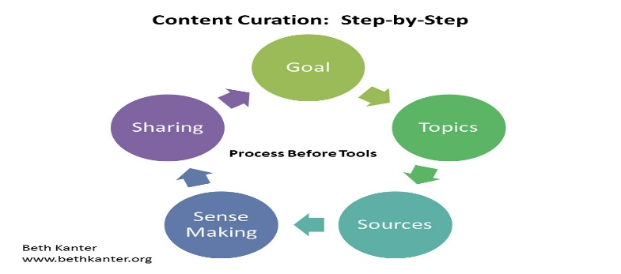

**Content Creation and Curation for Kay Beauty**

Content creation and curation are critical aspects of building brand awareness, engaging your target audience, and driving traffic to your website. For **Kay Beauty**, content should be informative, visually appealing, and aligned with its brand values of inclusivity, sustainability, and empowerment. Here's a strategy for content creation and curation:

**1. Content Creation Strategy**

**Content creation** involves producing original material that will resonate with your audience, promote your products, and elevate the brand’s identity. Here's how Kay Beauty can approach it:

**a. Visual Content**

1. **High-Quality Product Photos:**
   * **Purpose:** Showcasing Kay Beauty’s products in real-life settings.
   * **What to include:** Clear product shots, swatches on different skin tones, before-and-after images, and lifestyle images of users applying the products.
   * **Why it works:** Visual content is highly engaging, especially for beauty brands. It helps customers envision how products will look on them and builds trust through transparency.
2. **Makeup Tutorials & Demonstrations (Videos and Reels):**
   * **Purpose:** Educate your audience on how to use Kay Beauty products effectively.
   * **What to include:** Short-form tutorials for Instagram and TikTok, demonstrating the application of makeup products. For example, a quick guide on how to apply foundation for oily skin or creating an eye-catching look using Kay Beauty eyeshadows.
   * **Why it works:** Video content is highly engaging and encourages users to spend more time interacting with your brand. Tutorials also showcase the versatility of the products.
3. **User-Generated Content (UGC):**
   * **Purpose:** Feature your customers using Kay Beauty products.
   * **What to include:** Repost photos, reviews, or videos from satisfied customers on social media, featuring them in real-world settings.
   * **Why it works:** UGC helps build a sense of community and trust. Potential buyers feel more confident purchasing products that real customers recommend.
4. **Behind-the-Scenes Content:**
   * **Purpose:** Show the process of creating and developing Kay Beauty products.
   * **What to include:** Posts or short videos about the sustainability of packaging, the process of making the products cruelty-free, or the development of new makeup lines.
   * **Why it works:** Behind-the-scenes content humanizes the brand, showing customers that the brand values authenticity, quality, and sustainability.

**b. Written Content**

1. **Blog Posts:**
   * **Purpose:** Position Kay Beauty as an expert in the beauty industry while driving traffic to the website.
   * **What to include:** In-depth articles on topics like "How to Find the Right Foundation Shade," "Benefits of Vegan Makeup," "How to Build a Sustainable Beauty Routine," or "Best Makeup Products for Sensitive Skin."
   * **Why it works:** Blog posts are great for long-tail SEO, which helps rank your website on search engines. They can also educate your audience and solve common problems.
2. **Product Descriptions:**
   * **Purpose:** Provide detailed and enticing descriptions for each product on your website.
   * **What to include:** Highlight key benefits, ingredients, and the unique value proposition of each product (e.g., "long-lasting", "cruelty-free", "buildable coverage"). Include keywords like "inclusive beauty" or "best vegan lipstick" to boost SEO.
   * **Why it works:** Good product descriptions help potential buyers make informed decisions and also contribute to improving search engine rankings.
3. **Customer Reviews and Testimonials:**
   * **Purpose:** Build trust with your audience.
   * **What to include:** Positive reviews and success stories from customers about their experience with Kay Beauty products.
   * **Why it works:** Reviews and testimonials provide social proof and help prospective buyers feel more confident in their purchase decisions.

**c. Interactive Content**

1. **Polls and Quizzes (Instagram/TikTok Stories or Website):**
   * **Purpose:** Engage your audience in a fun, interactive way while gathering insights on their preferences.
   * **What to include:** Create quizzes to help customers find their perfect product (e.g., "Which Kay Beauty Foundation Shade Is Right for You?") or polls on social media about makeup preferences.
   * **Why it works:** Polls and quizzes provide value by helping users find products tailored to their needs, creating a more personalized shopping experience.
2. **Live Streaming and Q&A Sessions:**
   * **Purpose:** Directly engage with your audience in real-time and showcase Kay Beauty products.
   * **What to include:** Host live sessions on Instagram, Facebook, or YouTube, where beauty experts or influencers answer questions, demonstrate products, or discuss beauty trends.
   * **Why it works:** Live streaming helps connect directly with your community, building trust and loyalty. It also creates real-time opportunities for product recommendations and customer interaction.

**2. Content Curation Strategy**

**Content curation** involves gathering and sharing third-party content that complements your brand and provides value to your audience. This strategy helps position Kay Beauty as a thought leader while fostering a sense of community around beauty and self-care.

**a. Curated Social Media Posts**

1. **Sharing Industry News and Trends:**
   * **Purpose:** Keep your audience informed about the latest beauty trends, product innovations, or sustainability initiatives.
   * **What to include:** Share articles or studies related to the beauty industry, sustainability in beauty products, or new makeup trends.
   * **Why it works:** Curating relevant content builds your credibility as a trusted resource in the beauty industry.
2. **Spotlight on Influencers or Brand Ambassadors:**
   * **Purpose:** Share content from influencers or ambassadors who align with Kay Beauty’s values.
   * **What to include:** Repost makeup looks, product reviews, or tutorials from influencers who use and endorse Kay Beauty products.
   * **Why it works:** It highlights real-life examples of how Kay Beauty products can be used and helps create a sense of community and inclusivity.
3. **Customer Spotlights:**
   * **Purpose:** Showcase the stories of your customers.
   * **What to include:** Repost photos, videos, or quotes from happy customers who share their experiences with Kay Beauty products.
   * **Why it works:** Showcasing your customers fosters a sense of community and authenticity.

**b. User-Generated Content (UGC)**

* **Purpose:** Engage with your customers and let them share their experiences with Kay Beauty’s products.
* **What to include:** Encourage customers to tag Kay Beauty in their makeup posts or use branded hashtags like #KayBeautyLooks or #KayBeautySelfLove.
* **Why it works:** UGC is one of the most authentic forms of content. It not only increases brand visibility but also helps build a sense of community.

**Conclusion**

By combining both **content creation** (producing original and engaging material) and **content curation** (sharing valuable, third-party content), Kay Beauty can establish itself as an authority in the beauty industry, build stronger relationships with its audience, and increase brand loyalty. A well-rounded content strategy that is visually appealing, informative, and interactive will not only help grow the brand but also create an inclusive and empowering beauty community.

Would you like more help with creating specific content ideas or setting up your content calendar?